AI ASSISTANT CODING
ASSIGNMENT 2.1
2303A51839 VENNAM JAHNAVI

TASK 1: Statistical Summary for Survey Data
Scenario:
You are a data analyst intern working with survey responses stored as
numerical lists.
PROMPT:
generate a Python function that reads a list of numbers and calculates the mean, minimum, and maximum values with Correct Python function and Output shown in
Colab
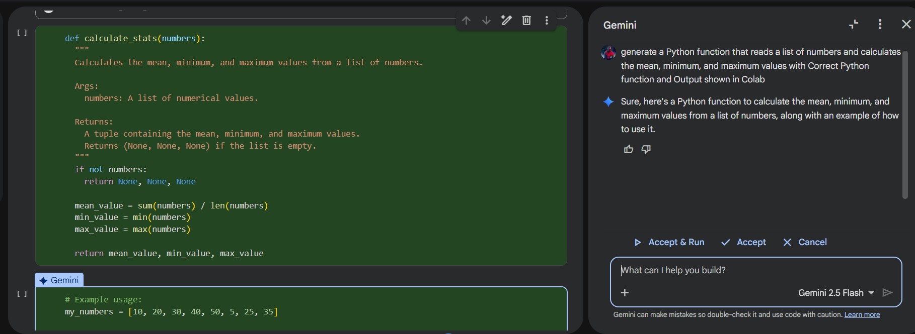
OUTPUT:
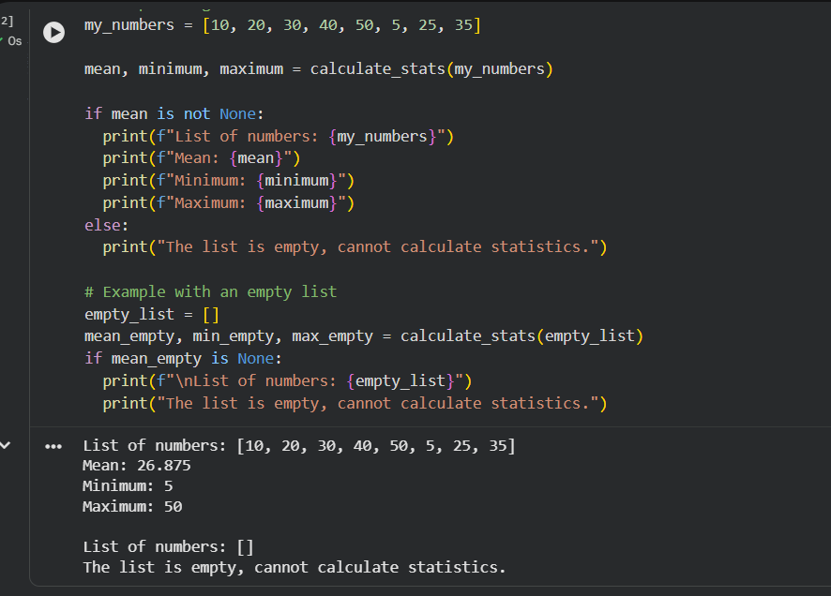

TASK 2: Armstrong Number – AI Comparison
Scenario:
You are evaluating AI tools for numeric validation logic.
PROMPT: generate an armstrong number checker code
GEMINI CODE:
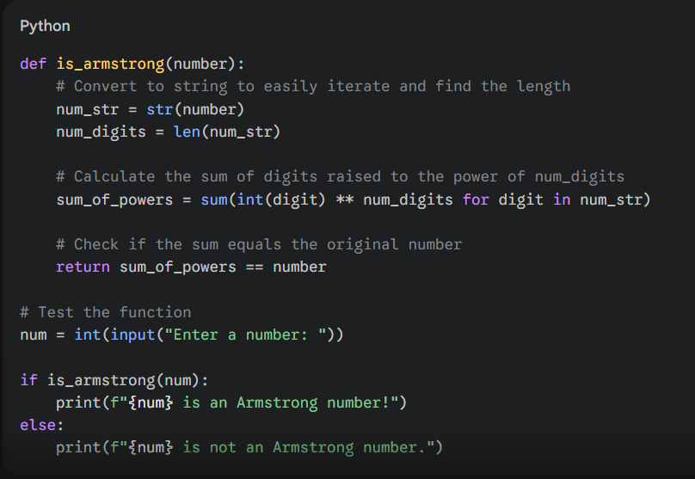
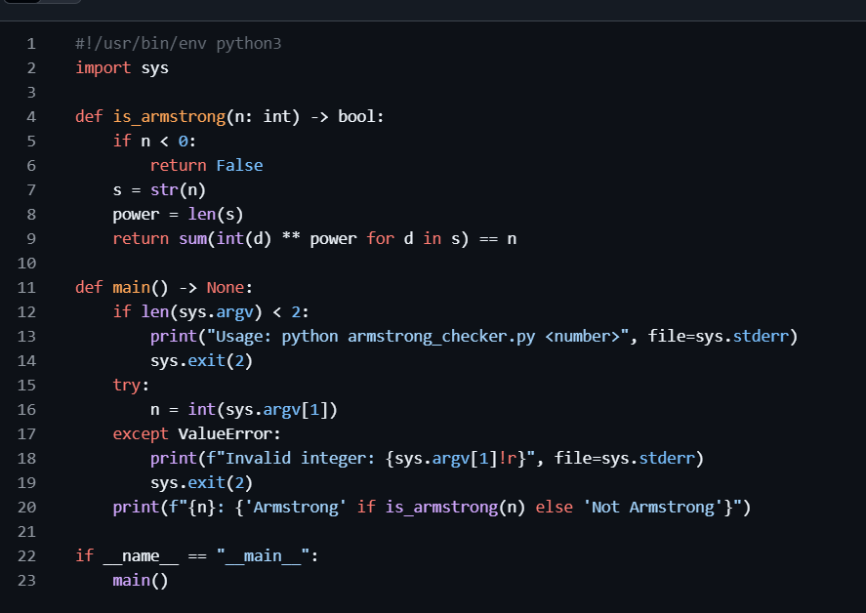
GITHUB CO PILOT CODE:
Aspect | GitHub Copilot Code | Gemini Code
Input Method | Command-line argument using sys.argv | User input using input()
Execution Style | Script-style (terminal-based, professional) | Interactive (beginner-friendly)
Output Format | <number>: Armstrong / Not Armstrong | <number> is / is not an Armstrong number!
Negative Number Handling | Explicitly checks n < 0 and returns False | ❌ No explicit negative number handling
Error Handling | ✔ Robust (handles missing input & invalid integers) | ❌ No error handling (crashes if input is invalid)
Function Definition | Uses type hints (n: int -> bool) | No type hints
Logic Used | Converts number to string, uses digit power sum | Same logic (string + digit power sum)
Reusability | ✔ High (modular, reusable, CLI-ready) | ⚠ Medium (tied to user input)
Clarity of Code | More professional, slightly complex | Very simple and easy to understand
Best For | Production scripts, automation, CLI tools | Beginners, learning concepts

Task 3: Leap Year Validation Using Cursor AI
❖ Scenario:
You are validating a calendar module for a backend system.
PROMPT1 : "Write a simple Python program to check whether a given year is a leap year using if-else conditions.
CODE: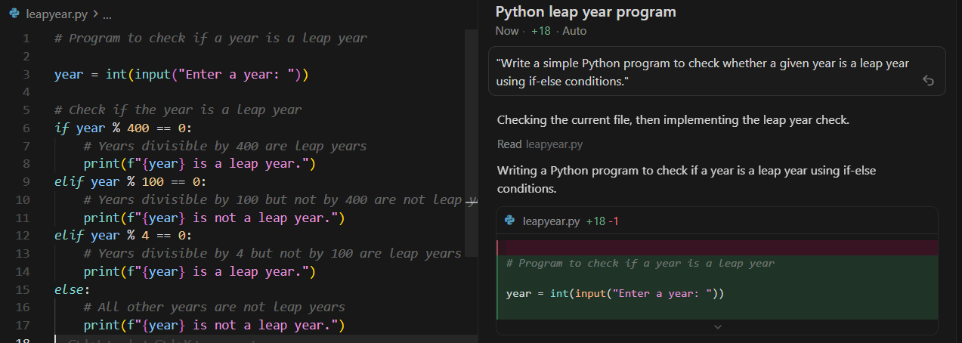
INPUT: 2024
OUTPUT: LEAP YEAR
PROMPT 2: Generate a professional Python program using functions and error handling to validate whether a given year is a leap year for a backend system.
CODE:
def is_leap_year(year: int) -> bool:
if year % 400 == 0:
return True
if year % 100 == 0:
return False
if year % 4 == 0:
return True
return False
2
def validate_year(year) -> dict:
try:
year_int = int(year)
is_leap = is_leap_year(year_int)
return {
'year': year_int
'is_leap': is_leap,
'status': 'success'
}
except (TypeError, ValueError) as e:
return {
'year': year,
'is_leap': False,
'status': 'error',
'message': str(e)
}
INPUT /OUTPUT:
{
'year': 2024,
'is_leap': True,
'status': 'success'
}
EXPLANATION: Prompt 1 produces a direct printed result, while Prompt 2 produces a structured and validated output.

TASK 4: Student Logic + AI Refactoring (Odd/Even Sum)
❖ Scenario: Company policy requires developers to write logic before using AI.
CODE: numbers = (1, 2, 3, 4, 5, 6, 7, 8, 9)

even_sum = 0
odd_sum = 0

for num in numbers:
if num % 2 == 0:
even_sum = even_sum + num
else:
odd_sum = odd_sum + num

print("Sum of even numbers:", even_sum)
print("Sum of odd numbers:", odd_sum)
REFACTORING CODE PROMPT: Refactor the given Python program that calculates the sum of odd and even numbers in a tuple.
Optimize the code using Python best practices, reduce lines of code, and improve readability without changing the output.
CODE:
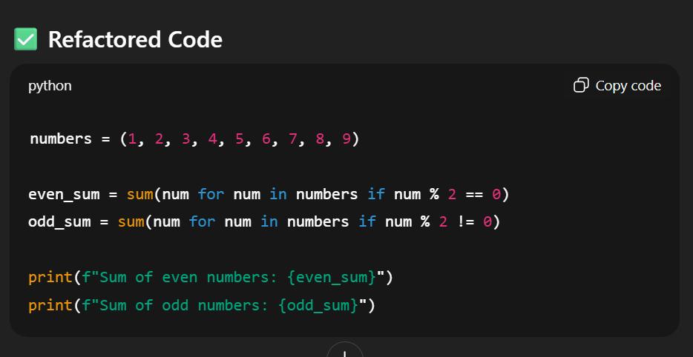
OUTPUT:
Sum of even numbers:
Sum of odd numbers:
EXPLANATION:
- Replaced manual loops with Python’s built-in sum() and generator expressions.
- Reduced code length and improved clarity without changing the program output.

